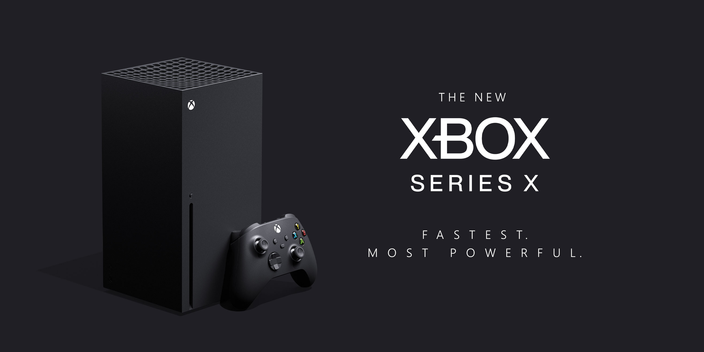

**Xbox Series X**

**Price: $499**

**Description:** The Xbox Series X has higher end hardware and supports higher display resolutions (up to 8K resolution), along with higher frame rates and real-time ray tracing; it also has a high-speed solid-state drive to reduce loading times.

**System Specifications:**

* CPU: 3.8-GHz AMD Zen 2-based processor.
* GPU: 12-teraflop AMD RDNA 2 GPU with 52 Compute Units (CU)
* Memory: 16 GB.
* Storage: 1 TB NV Me SSD

**Developed By:**

